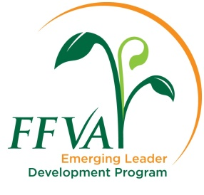

2023 - 2024
Class 13 Application
No Handwritten Copies
Deadline: June 16, 2023

1. Personal and Contact Information

Name: | Title:
Company: | Email:
Mailing address: | Age:
City, State and ZIP: | Marital status:
Cell phone: | Work phone:

2. Education – List higher education, including short courses or continuing education.

School: | School:
Dates attended: | Dates attended:
Graduation date: | Graduation date:
Degree: | Degree:

3. Primary Occupation

Commodities grown/Line of work:________________________________________________

4. Employment History − including current job

Company:
Dates:
Job responsibilities:

Company:
Dates:
Job responsibilities:

5. Volunteer Activity – List any membership, dates of service and offices held (if any) in organizations including college, professional, civic, church, industry organization or political.

6. References – List two references. Cannot be a family member, and must include one person not in your company. References will be contacted. Make sure your references know you are listing them.

Name: | Title:
Company: | Phone:
Email: | Relationship:
Years known:

Name: | Title:
Company: | Phone:
Email: | Relationship:
Years known:

7. In 250 words or fewer, explain why you would like to participate in the FFVA Emerging Leader Development Program (including your leadership strengths and potential).

8. List three objectives you would like to achieve by participating in this program.

9. In 250 words or fewer, describe both the major challenges and the major opportunities facing the Florida specialty crop industry.

10. Participants in FFVA’s ELDP program have gone on to advocate for the industry before policymakers and serve in a variety of leadership roles, including on FFVA’s board of directors. In 250 words or fewer, if selected to participate in this program, explain how you plan to become more involved in the association and our industry.

2023-2024 Schedule
Session | Date | Subject/Issue | Location
FFVA 101 | Oct/Nov 2023 | Current issues | FFVA office  Maitland, FL
Production Trip 1 | December 2023 | Florida production | TBD
Legislative Visit | January 2024 | Public policy | Tallahassee
Production trip 2 | March 2024 | Florida production | TBD
California trip | June/July 2024 | Western production | California
FFVA Convention | Sept. 16-18, 2024 | Graduation | JW Marriott,  Marco Island, FL

